PIZZA SALE SQL QUERY

1.KPI’S

1.Total Revenue:

select sum(total_price) from pizza_orders;



2. average Order Value

select round(sum(total_price)/count(distinct(order_id)),2) from pizza_orders;



3.Total Pizzas Sold

select sum(quantity) as Total_pizza_sold from pizza_orders;



4.Total Orders

select count(distinct(order_id)) as Total_Orders from pizza_orders;

5.Avarge Pizzas Per Orders

select round(sum(quantity) / count(distinct(order_id)),2) as avg_pizza_sold_per_order from pizza_orders



B. DAILY TREND FOR TOTAL ORDERS

select dayname(order_date) as Order_day , count(distinct(order_id)) as number_of_Orders from pizza_orders

group by Order_day order by number_of_orders desc;

C.HOURLY TRENDS FOR TOTAL ORDERS

select hour(order_time) as Order_Hour , count(distinct(order_id)) as number_of_Orders from pizza_orders

group by Order_Hour order by number_of_orders desc;

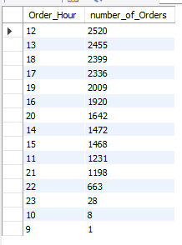

D.MONTHLY TREND FOR TOTAL ORDERS :

select monthname(order_date) as Order_day , count(distinct(order_id)) as number_of_Orders from pizza_orders

group by Order_day order by number_of_orders desc;

E. PERCENTAGE OF SALES BY PIZZA CATEGORY

SELECT

pizza_category,

CAST(SUM(total_price) AS DECIMAL(10,2)) AS total_revenue,

CAST(SUM(total_price) * 100 / (SELECT SUM(total_price) FROM pizza_orders) AS DECIMAL(10,2)) AS `%`

FROM pizza_orders

GROUP BY pizza_category;

F. % OF SALES BY PIZZA SIZE

SELECT

pizza_size,

SUM(total_price) AS total_revenue,

CONCAT(ROUND(SUM(total_price) * 100 / (SELECT SUM(total_price) FROM pizza_orders), 2), '%') AS `%`

FROM pizza_orders

GROUP BY pizza_size;

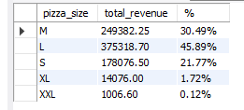

G. TOTAL PIZZAS SOLD BY PIZZA CATEGORY

Select distinct(pizza_category),sum(quantity) over(partition by pizza_category) from pizza_orders

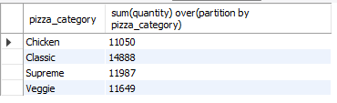

H. TOP 5 PIZZA BY REVENUE

Select distinct (Pizza_name),sum(Total_price) over(partition by Pizza_name) as Revenue from pizza_orders order by Revenue desc limit 5;

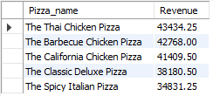

I. BOTTOM 5 PIZZA BY REVENUE

Select distinct (Pizza_name),sum(Total_price) over(partition by Pizza_name) as Revenue from pizza_orders order by Revenue limit 5;

J. TOP 5 PIZZAS BY QUANTITY

Select distinct (Pizza_name),sum(Quantity) over(partition by Pizza_name) as T_Quantity from pizza_orders order by T_Quantity desc limit 5;

K. BOTTOM 5 PIZZAS BY QUANTITY

Select distinct (Pizza_name),sum(Quantity) over(partition by Pizza_name) as T_Quantity from pizza_orders order by T_Quantity limit 5;

L.TOP 5 PIZZAS BY TOTAL ORDERS

SELECT Pizza_name, COUNT(DISTINCT Order_id) AS Orders

FROM pizza_orders

GROUP BY Pizza_name

ORDER BY Orders DESC

LIMIT 5;

M. BOTTOM 5 PIZZAS BY TOTAL ORDERS

SELECT Pizza_name, COUNT(DISTINCT Order_id) AS Orders

FROM pizza_orders

GROUP BY Pizza_name

ORDER BY Orders DESC

LIMIT 5;

